Agriculture Demand Change Management, A Price Predicting and Crop Yield Forecasting Model.



Submitted to:

Mr. Vinayak Kamble,

Lead - Education,

Training & Assessment, ETA,

Submitted by:

Jilu Mary Alias

Roll No: SNG16MCA8

Course: MCA,

SNGCE, Kadayiruppu

# Project Completion Declaration Performa

I hereby declare that the project entitled “Agriculture Demand Change Management, A Price Predicting and Crop Yield Forecasting Model” done by *Jilu Mary Alias* is complete in all respects to my satisfaction and is ready for final evaluation in partial fulfillment of the degree of MCA. As per my knowledge the project is an original work done under my guidance and not copied from elsewhere. Any material used from other sources has been clearly identified and will be properly acknowledged and referenced in the final report.

Date: _____________

Signature of Guide

Mr. Vinayak Kamble,

Lead - Education, Training & Assessment,

Contents

2

Acknowledgement 4

Introduction 5

Company Profile 5

Infosys has expertise in: 5

Abstract 6

Aim: 6

Objective: 6

Application of Software Engineering 6

Implementation of Software Development Life Cycles (SDLC): 6

Methodology 7

Result 7

Learnings 8

Theoretical Learning: 8

Applied Learning: 10

Stage 1. Learning Technologies: (4 weeks) 11

Stage 2. Designing: (4 weeks) 11

Stage 3. Implementation: (1 week) 15

Stage 4. Testing: (1 week) 20

Conclusion 21

# Acknowledgement

The successful completion of any task would be incomplete, without mentioning the people, whose constant guidance and encouragement crown all efforts with success.

I am grateful to my project mentor Mr. Vinayak Kamble, Lead - Education, Training & Assessment, ETA, Infosys Limited, Mysore, for allowing me to carry out my project under their guidance at this esteemed organization during the internship period.

Our thanks and gratitude to the entire Education, Training & Assessment, Infosys Limited, Mysore, for their extended support and guidance.

In extension of this acknowledgement I would also express my deep regards to

Mr. Chandrakantha Malligere, Lead - Education, Training & Assessment, ETA, Infosys Limited, Mysore, for coming up with such a unique project idea and allowing us to carry it out.

I choose this moment to acknowledge their contributions gratefully.

Sincerely,

Jilu Mary Alias

Place: Mysore.

# Introduction

## Company Profile

Infosys Limited is an Indian [multinational corporation](https://en.wikipedia.org/wiki/Multinational_corporation) that provides [business consulting](https://en.wikipedia.org/wiki/Business_consulting), [information technology](https://en.wikipedia.org/wiki/Information_technology) and [outsourcing](https://en.wikipedia.org/wiki/Outsourcing) services. It is a global leader in next-generation digital services and consulting that enables clients in 45 countries to navigate their digital transformation

## Infosys has expertise in:

* Business Process Outsourcing.
* It-Consultancy.
* Technology-Enabled Transformation Programs.
* Business Consulting.
* Technology Solutions.
* Automation Technology.
* Mobile Commerce and Digital Marketing Service.
* Advanced Information Management Consulting Services.

The portfolio of Infosys IT Solutions and services ranges from consulting, software deployment and system integration to the comprehensive management of IT infrastructures.

In my learning, I evolved as an efficient professional. My experience with the company has enhanced my skills and has contributed towards my professional and personal development. I look forward to be a part of this esteemed organization, as I can relate to its culture and values.

# Abstract

As a part of my B.Tech curriculum, I have done my Internship in Infosys, Mysore. In this report, I am going to share my experience of the internship period of 14 weeks in the company.

During this period, my role was to study the different software technologies; I was given the task to document and develop a Price Predicting and Crop Yield Forecasting Model, for predicting the price of a crop at any given point of time and in a given geographical region.

## Aim:

As a fresher my aim was to understand the concepts of different software technologies I learnt and comprehend the different methods of delivering the solutions in defined way.

## Objective:

### Application of Software Engineering

* Software engineering is the application of engineering to the development of software in a systematic method.
* The idea of software programming is based on the very fundamental principle of “The systematic application of methods and experience to design, implement, testing and documentation of software.”

### Implementation of Software Development Life Cycles (SDLC):

* The software development life cycle is a process for planning, creating, testing and deploying a software system.
* The life cycle defines the methodology for improving the quality of software and the overall development process.

## Methodology

During the internship, I was in the company with the capacity of an intern.

The methodology used for this training was applied learning, in which I had to apply the theoretical knowledge to derive a solution for a given problem statement.

I experimented on different areas of software development like product backlog, scrums, and understanding the technicalities of Software Engineering.

## Result

My whole study during the period of internship has resulted into my core understanding of software development and the technologies used.

# Learnings

As a part of an esteemed organization I had been appointed with certain roles and responsibilities. I was working as an intern for the design and development of a Price Predicting and Crop Yield Forecasting Model.

## Theoretical Learning:

The following figure is a graphical representation of the various stages of a typical Software Development Life Cycle (SDLC).

A typical Software Development Life Cycle consists of the following stages:

1. Requirement and feasibility Analysis – Collecting information from the customer, and then using it to plan the basic project approach, and to conduct project feasibility study.

The next step is to define and document the product requirements through a Software Requirement Specification (SRS) document.

1. Designing – In this stage the basic system outline is prepared from the requirement specifications which were studied in the first stage. Design helps in specifying hardware, software requirements, and the overall system requirements.
2. Implementation – In this stage the work is divided in modules and actual coding is started. This is the longest stage if the SDLC.
3. Testing – After the code is developed it is tested against the requirements to make sure that the product is actually solving the needs identified during the requirement stage.
4. Deployment – After the successful testing the product is delivered to the customer for their use. The customer then performs beta testing and if any bugs are found or changes are required the software developing team is informed. Once the final changes are made the final deployment takes place.
5. Maintenance – Product maintenance is performed time to time.

## Applied Learning:

There are different approaches to develop software, but I was given the Agile Methodology for my project.

The Agile Model –

* Agile projects are developed in equal short time-boxed duration of time intervals known as **Sprints,** during which pre-determined features are developed and delivered.
* Agile projects can have one or more sprints and deliver working incremental versions of the software at the end of each sprint.
* At the end of the final sprint the product gets released with all the pre-determined features in place
* The basic idea behind this method is rapid delivery of business value in a constantly changing functional and technical landscape.

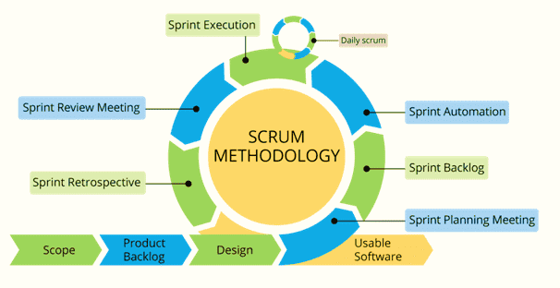

Figure: Agile Model SDLC

### Learning Technologies: (6 weeks)

I started off by following the Infosys training curriculum to learn the different technologies required to complete the project, since SRS was to be provided by the company itself.

The technologies included in the curriculum can be categorized in two categories:

1. Technologies used in Back-End
   1. JAVA.
   2. Spring framework.
   3. Hibernate framework.
2. Technologies used in Front-End
   1. Angular.
   2. HTML.
   3. CSS.
   4. Bootstrap.

After this, I, along with my team were provided with a Software Requirement Specification (SRS) document, which gave a detailed description of the requirements to be fulfilled by the tool.

After studying the requirements, we met with our mentor and our team began to plan our designing process, where we first made a vague outline of what the solution should be like and how we plan to approach it.

### Designing: (2 weeks)

Here we were given the task to follow the agile model to design the tool, and proceeded accordingly. We charted the Agile sheet to make it easier for other team members to continue the project.

We planned how the application tool would look like and what features it would contain, along with the database requirements of the tool. We tried to make the tool as user friendly as I could by:

* Taking minimal input from the users.
* Allowing easy upload/edit/updating of data.
* Providing reports in tabular format for easier calculations.

A rough idea of database was derived according to the project requirements, where tables needed in the database and relations amongst those tables were identified.

We decided which IDE and database would be apt for the project solution. I modified my requirements according to environmental constraints identified during the designing.

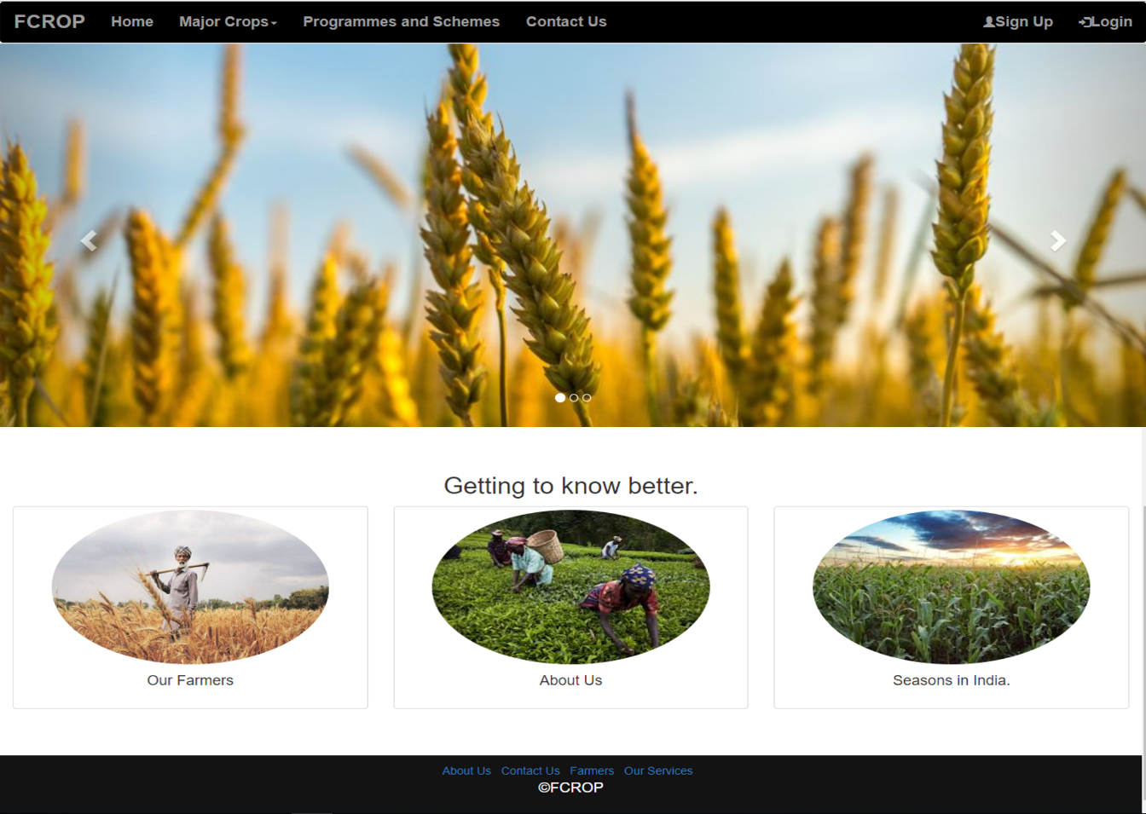The front end programming for this project would be done using HTML, CSS and Bootstrap; using Visual Studio and a customized version of Eclipse with Spring and Hibernate framework, as IDE. We then began to design our tool as a website and designing different components for the same.

The home page consisted of components like:

* 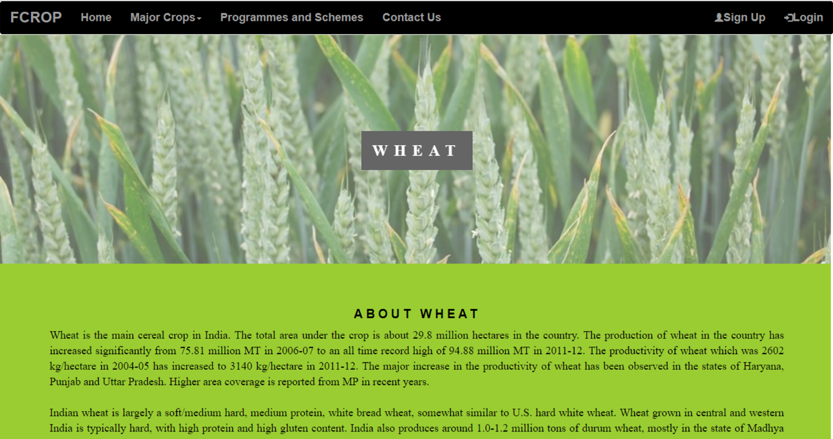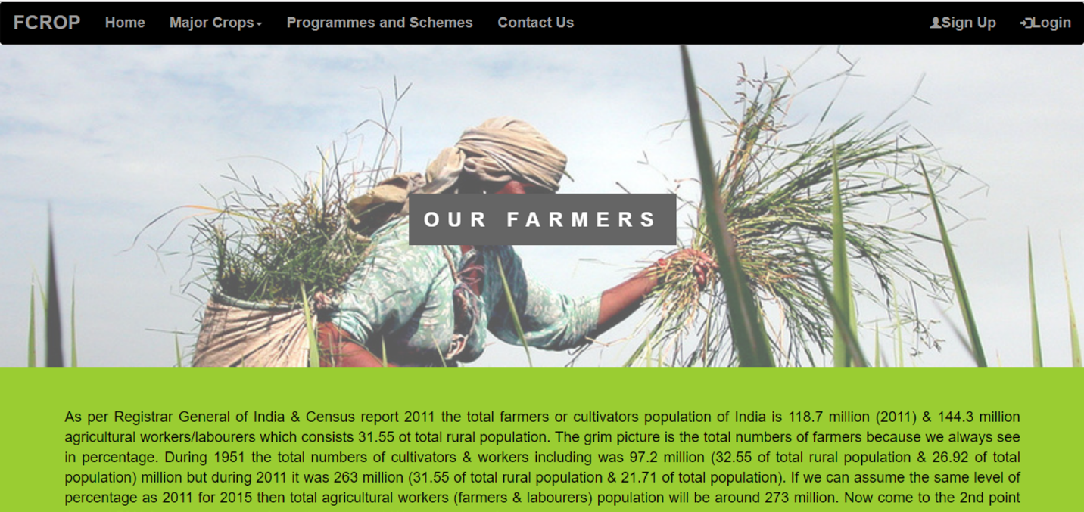Our farmer, that gives information about current situation of farmers in our country.
* Major Crops, that consists of crops majorly grown across the country.
* 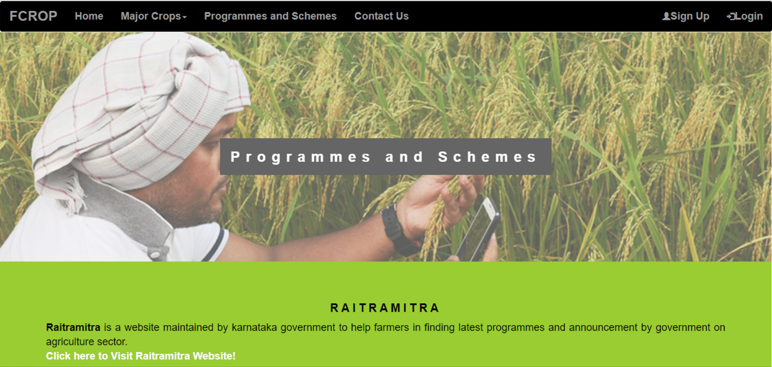Programmes and schemes, that consists of programmes and schemes provided by the government for farming aid.
* 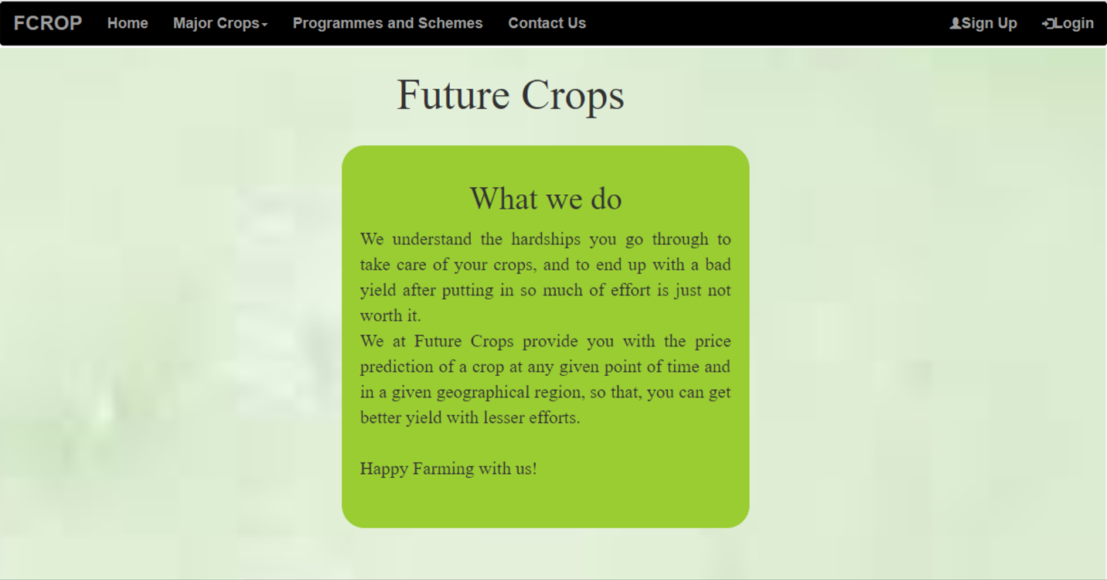Future Crops, that gives information about us.

### Implementation: (5 week)

In this phase the initial database was created by my team. This database was created using MySQL Database.

The initial database was then modified according to the user requirements and new data was added, the biggest impediment we faced with the data was the data was not organized and was not in the right format, so we had to devote a major part of our time in organizing data and designing the APIs.

Then we integrated the components with the APIs and started testing the functionality of them. We designed the following:

* 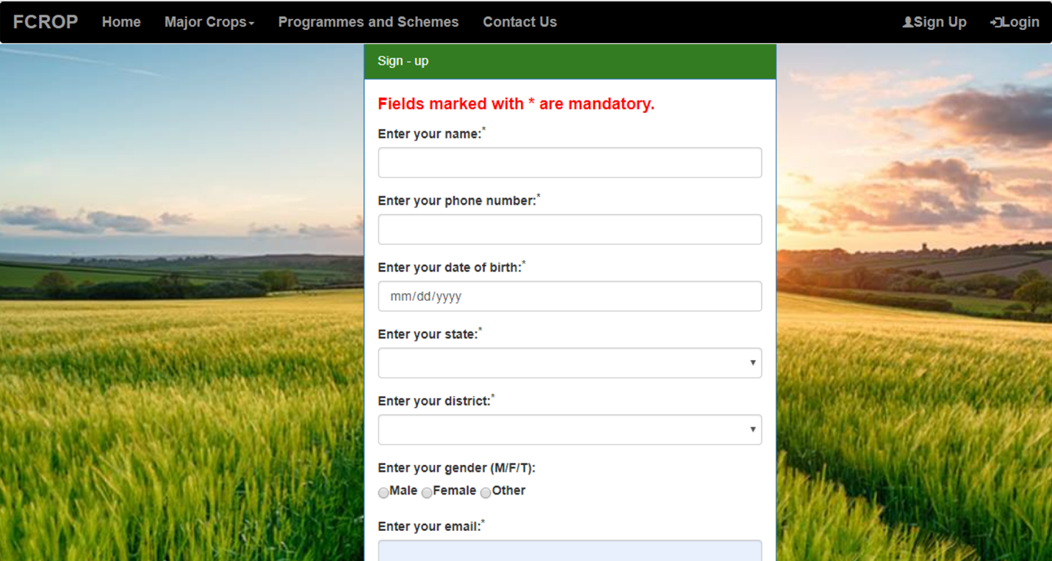Sign-up for users.
* 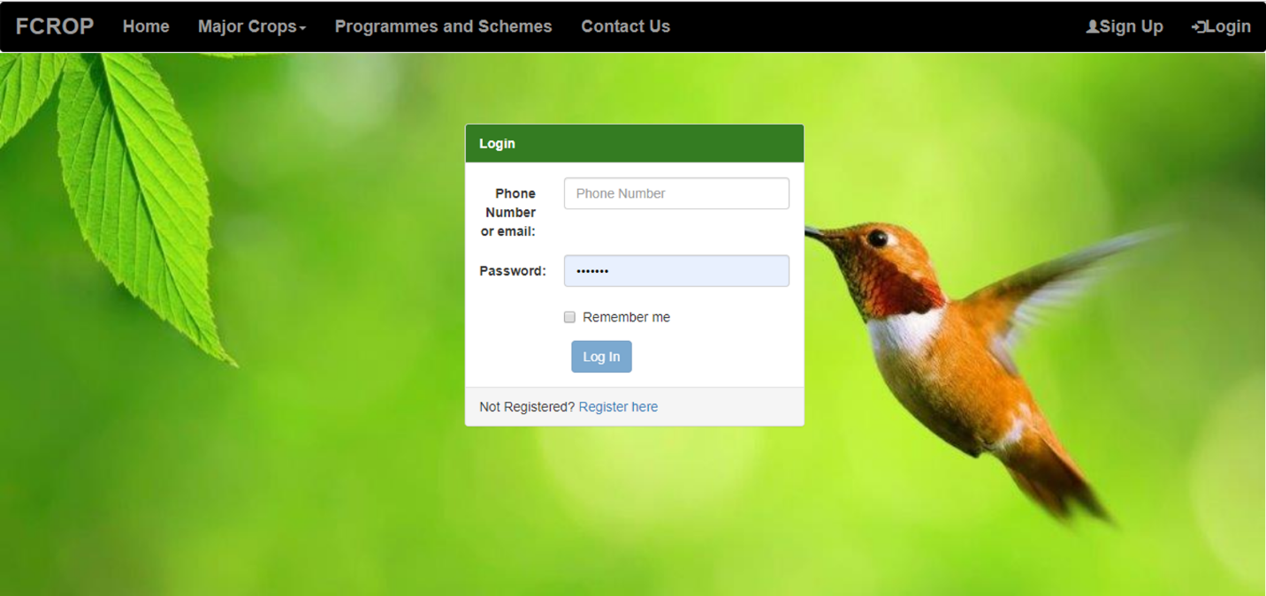Login for users who wish to use the services provided by the tool.
* 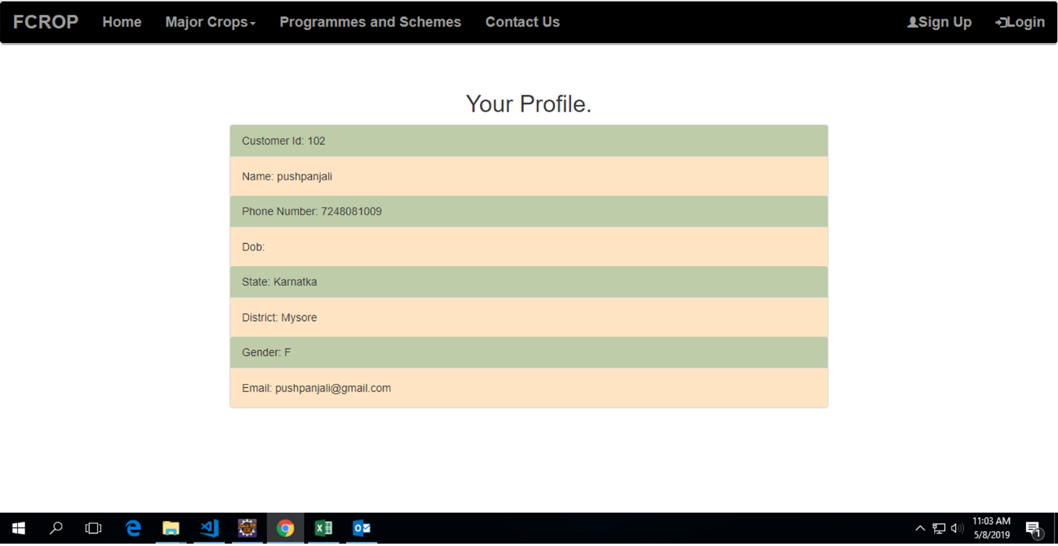Customer can view their profile details and modify them.
* 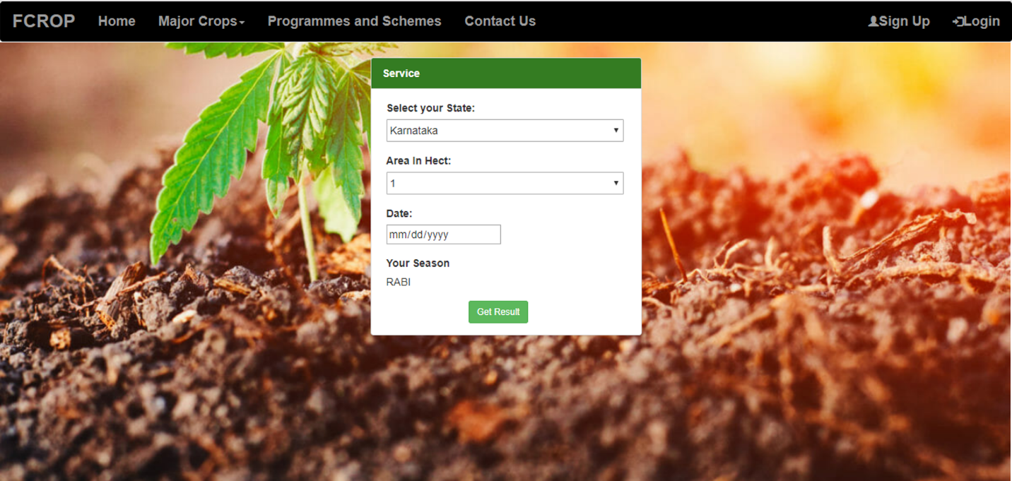A Registered User can find the best crop as per a particular season or as per the size of land.
* 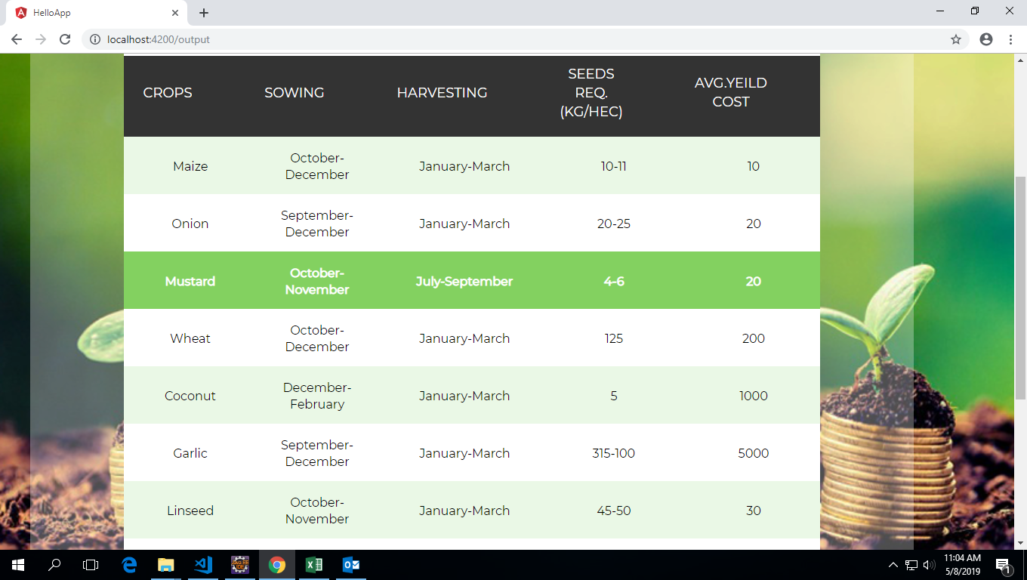A Registered User can check the future yield and cost of the crop (estimation)
* 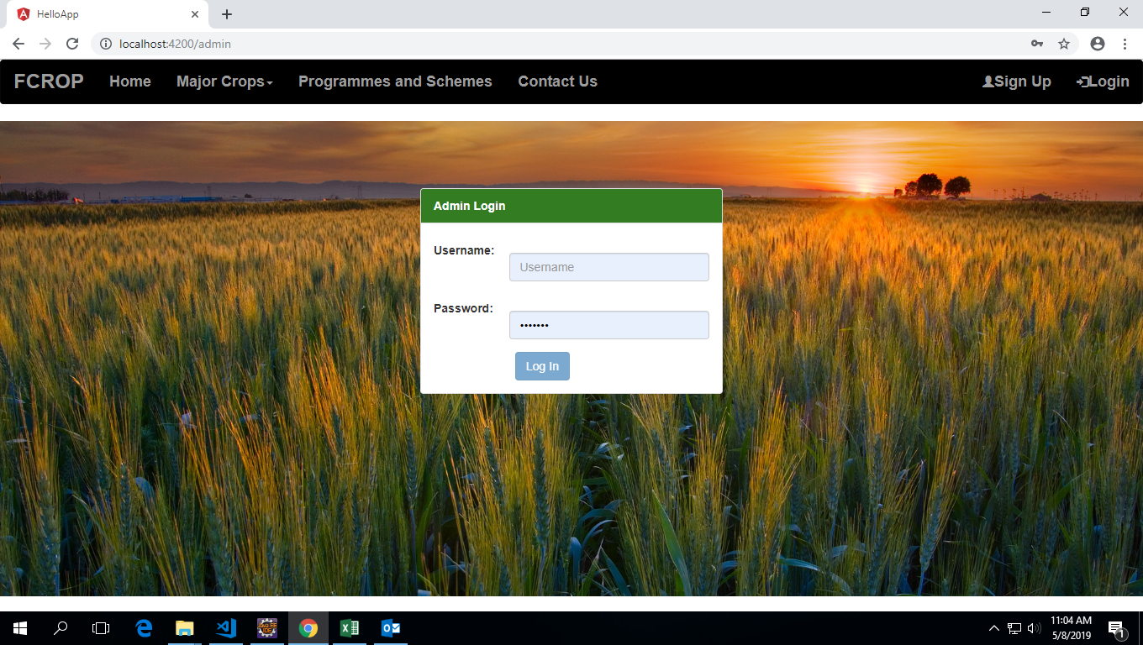We created an admin dashboard to support user queries and issues related to the project.
* 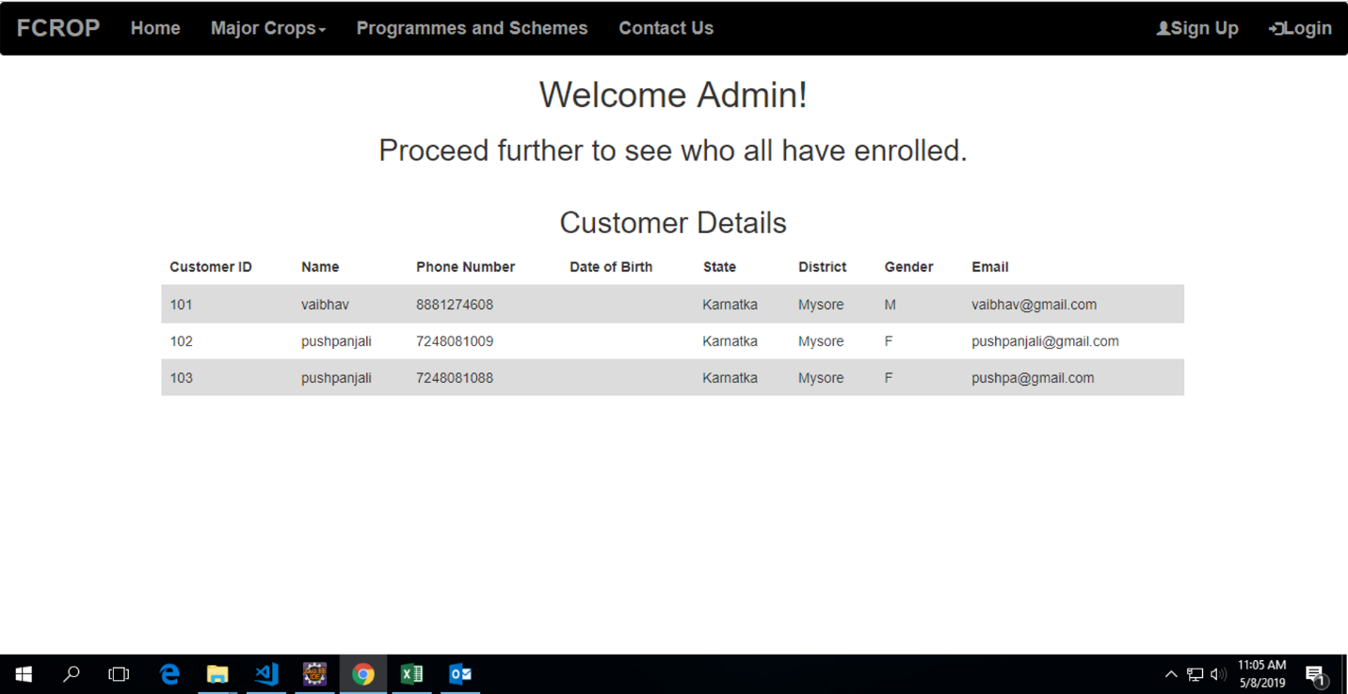Admin can view user profiles and reply to their queries.
* 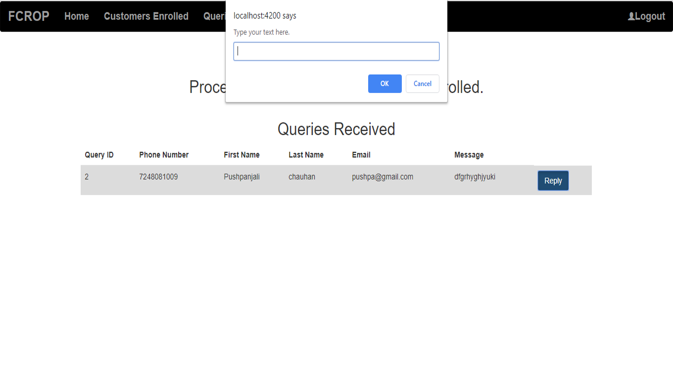Users can reach out to the admin using the contact-us component of the tool.

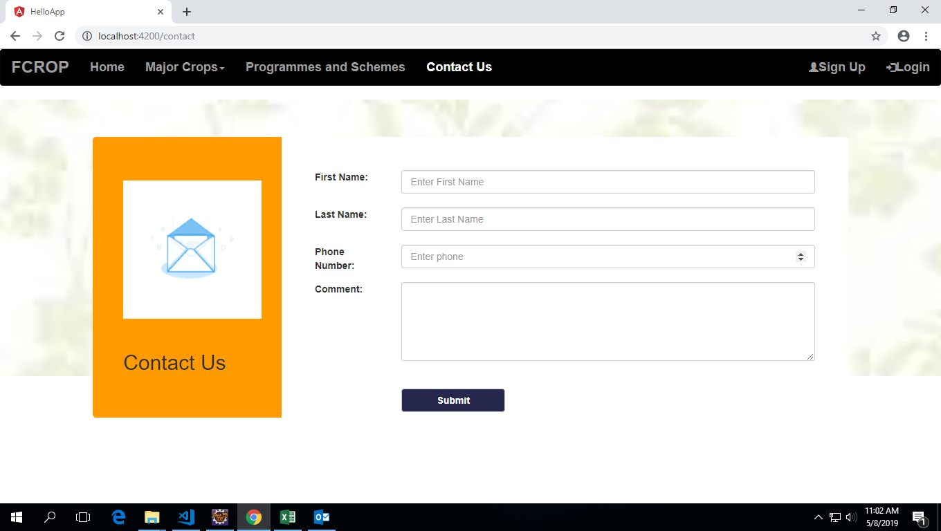

### Testing: (1 week)

An essential part of our project was testing it. During our curriculum we learnt that testing can be of different types. We performed unit and integrated testing on project after completion of each component.

As we progressed, we performed unit testing on individual components and post completion of those components we performed integrated testing after putting the components together.

Due to our time constraints we were only able to be the part of this project up till here.

# Conclusion

It has been a very enlightening journey for me in the organization; I learned a lot about the corporate environment and tools used by the professionals. I was able to understand the work flow of projects in software development and the roles and responsibilities of a software developer.

Although I had already worked on projects like this in the past, but working on a different IDE and working environment, and using a different set of programming language, helped me in becoming a better software developer; It helped me in realizing how I can add value to an organization even after just being a fresher.

Apart from this, I had some note-worthy discoveries & suggestions from different individuals around me which helped me in understanding the application of my learnings better.